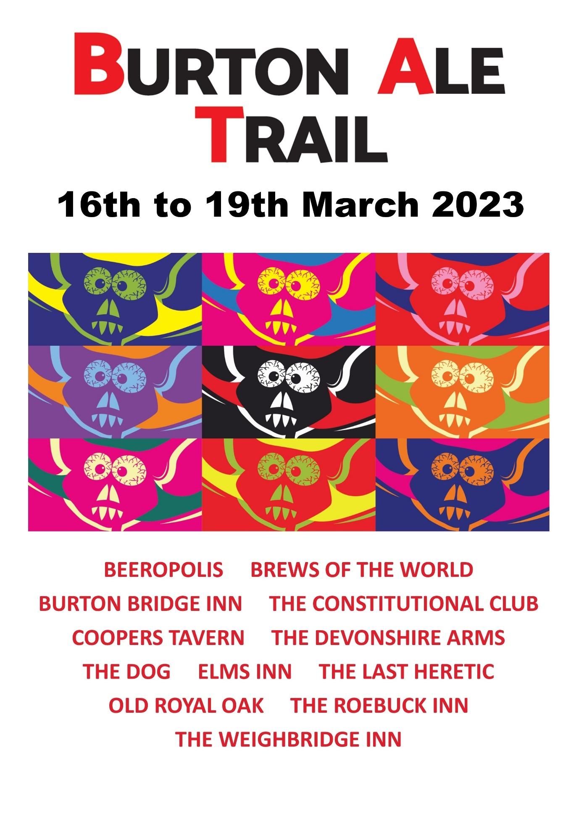

PROGRAMME
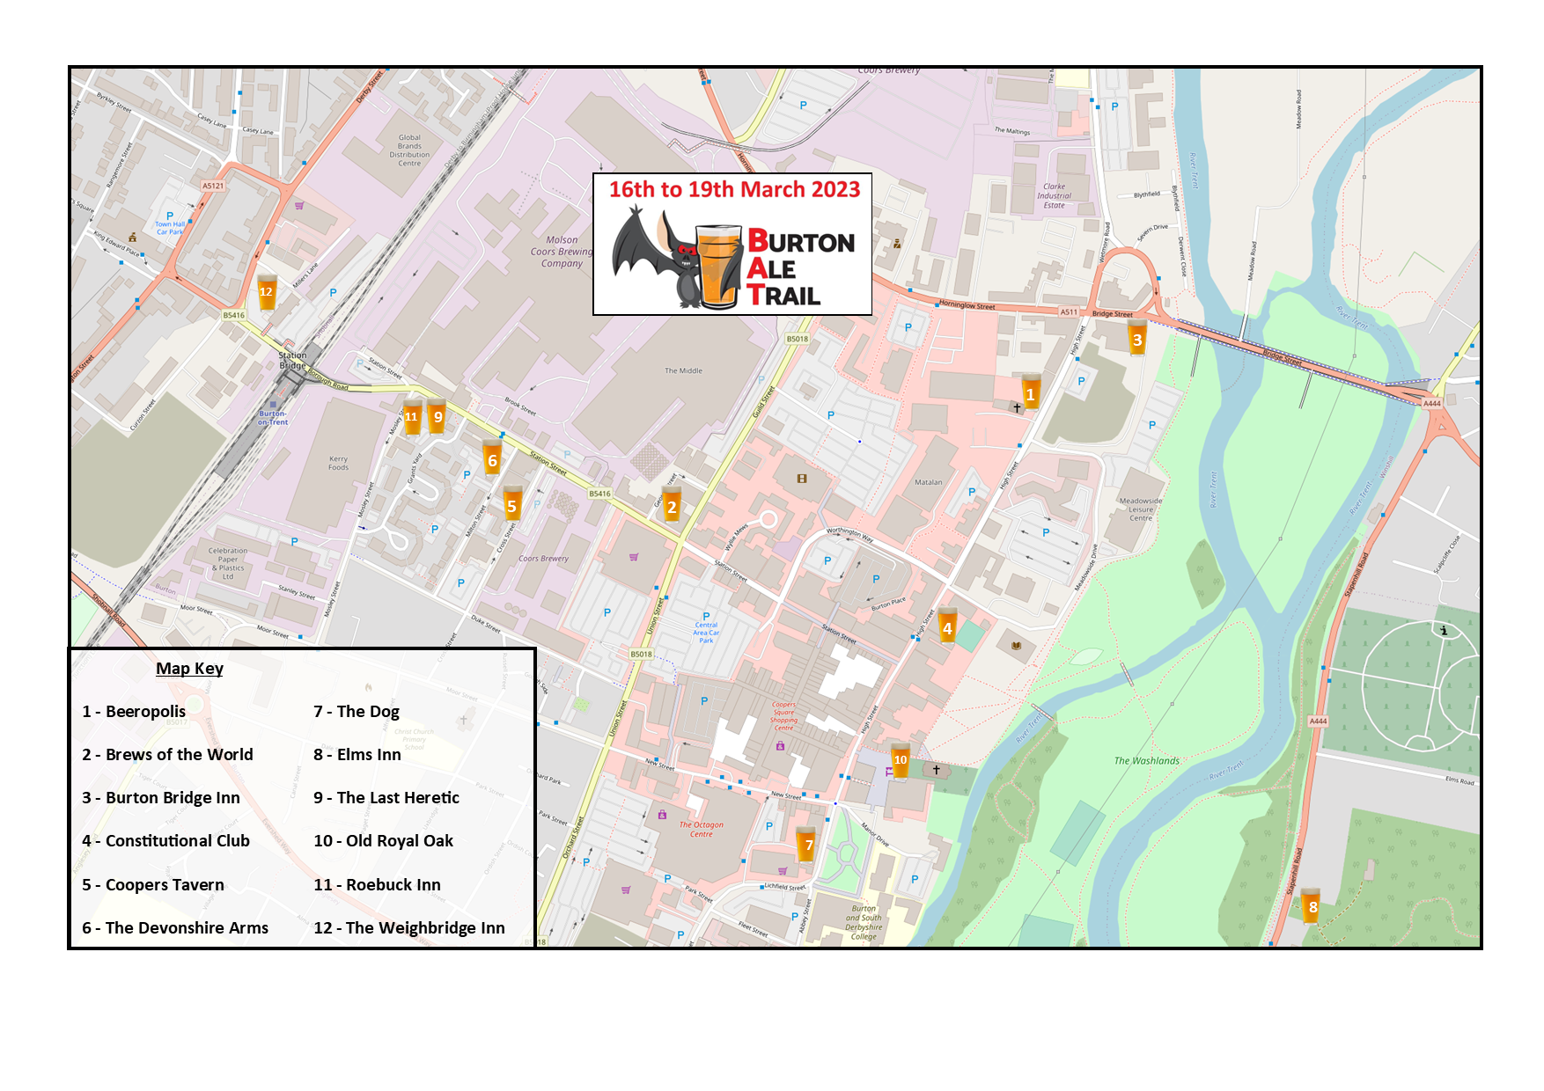
OPENING TIMES

THURSDAY

BEEROPOLIS 4pm to 10pm
BREWS OF THE WORLD 3pm to 11:30pm
BURTON BRIDGE INN 4pm to 10:30pm
THE CONSTITUTIONAL CLUB 11am to 11pm
COOPERS TAVERN 3pm to 11pm
THE DEVONSHIRE ARMS 4pm to 11pm
THE DOG 12pm to 11pm (Bar closed at 22:40pm)
ELMS INN 12pm to 11pm
THE LAST HERETIC 2pm to 10pm
OLD ROYAL OAK 2pm to 10:30pm (Last orders 10pm)
THE ROEBUCK INN 12pm to 11pm
THE WEIGHBRIDGE INN 2pm to 10pm (Last orders 9:30pm)

FRIDAY

BEEROPOLIS 12pm to 11pm
BREWS OF THE WORLD 12pm to 11:30pm
BURTON BRIDGE INN 12pm to 11pm
THE CONSTITUTIONAL CLUB 11am to 11pm
COOPERS TAVERN 12pm to 11pm
THE DEVONSHIRE ARMS 12pm to 11pm
THE DOG 12pm to 11pm (Bar closed at 22:40pm)
ELMS INN 12pm to 11pm
THE LAST HERETIC 2pm to 10:30pm
OLD ROYAL OAK 12pm to 12am (Last orders 11:30pm)
THE ROEBUCK INN 12pm to 11pm
THE WEIGHBRIDGE INN 2pm to 10pm (Last orders 9:30pm)
SATURDAY

BEEROPOLIS 12pm to 11pm
BREWS OF THE WORLD 12pm to 11:30pm
BURTON BRIDGE INN 12pm to 11pm
THE CONSTITUTIONAL CLUB 11am to 11pm
COOPERS TAVERN 12pm to 11pm (Last orders 10:40pm)
THE DEVONSHIRE ARMS 12pm to 11pm
THE DOG 12pm to 11pm (Bar closed at 22:40pm)
ELMS INN 12pm to 12pm
THE LAST HERETIC 11am to 11pm
OLD ROYAL OAK 12pm to 12am (Last orders 11:30pm)
THE ROEBUCK INN 12pm to 11pm
THE WEIGHBRIDGE INN 11:30 to 10pm (Last orders 9:30pm)

SUNDAY

BEEROPOLIS 12pm to 7pm (Later if it's still busy)
BREWS OF THE WORLD 12pm to 8pm
BURTON BRIDGE INN 7pm to 10:30pm
THE CONSTITUTIONAL CLUB 12pm to 11pm
COOPERS TAVERN 12pm to 7pm (Last orders 6:30pm)
THE DEVONSHIRE ARMS 12pm to 10:30pm
THE DOG 12pm to 6pm (Bar closed at 5:40pm)
ELMS INN 12pm to 10pm
THE LAST HERETIC 12pm to 7pm
OLD ROYAL OAK 12pm to 6.30pm (Last orders 6pm)
THE ROEBUCK INN 12 pm to 10pm
THE WEIGHBRIDGE INN 1:30 to 7pm (Last orders 6:30pm)

